**Tema 5**

Nume: Pop Maria

Grupa: 232

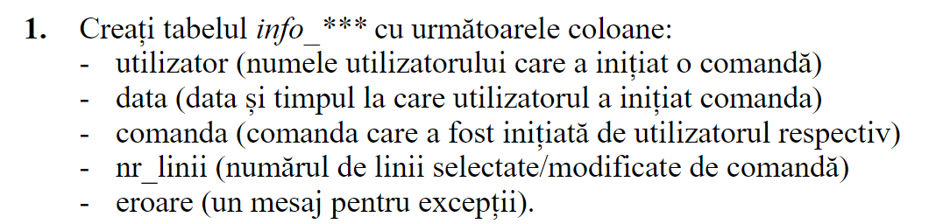

create table info_pm (

utilizator NVARCHAR2(40),

data DATE,

comanda NVARCHAR2(40),

nr_linii NUMBER,

eroare NVARCHAR2(100)

);

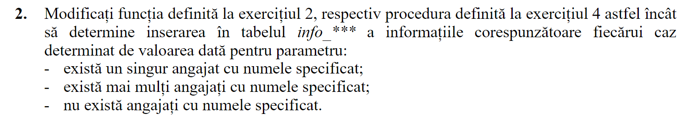

create or replace function f2_pm (

v_nume employees.last_name%TYPE DEFAULT 'Bell'

) return number is

salariu employees.salary%type;

begin

select salary

into salariu

from employees

where last_name = v_nume;

insert into info_pm values(user, sysdate, 'f2_pm', 1, NULL);

return salariu;

exception

when no_data_found then

insert into info_pm values(user, sysdate, 'f2_pm', 0, 'Nu exista angajatul');

raise_application_error(-20000, 'Nu exista angajati cu numele dat');

when too_many_rows then

insert into info_pm values (user, sysdate, 'f2_pm', 0, 'Exista mai multi angajati cu numele dat');

raise_application_error(-20001, 'Exista mai multi angajati cu numele dat');

when others then

insert into info_pm values(user, sysdate, 'f2_pm', 0, 'Alta eroare');

raise_application_error(-20002, 'Alta eroare');

end f2_pm;

------------------------------------------------

create or replace procedure p4_pm (

v_nume employees.last_name%type )

is

salariu employees.salary%type;

begin

select salary

into salariu

from employees

where last_name = v_nume;

dbms_output.put_line('Salariul este ' || salariu);

insert into info_pm values(user, sysdate, 'p4_pm', 1, NULL);

exception

when no_data_found then

insert into info_pm values(user, sysdate, 'p4_pm', 0, 'Nu exista angajatul');

raise_application_error(-20000, 'Nu exista angajati cu numele dat');

when too_many_rows then

insert into info_pm values(user, sysdate, 'p4_pm', 0, 'Exista mai multi angajati cu numele dat');

raise_application_error(-20001, 'Exista mai multi angajati cu numele dat');

when others then

insert into info_pm values(user, sysdate, 'p4_pm', 0, 'Alta eroare');

raise_application_error(-20002, 'Alta eroare!');

end p4_pm;

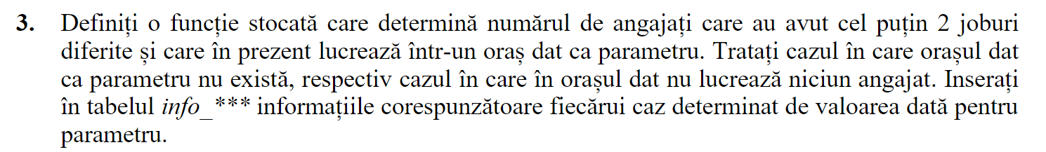

create or replace function f3_pm (

oras_curent locations.city%type default 'Oxford')

return number

is

loc number;

utilizator1 info_pm.utilizator%type;

nr_ang number;

begin

select user into utilizator1 from dual;

select count(1)

into loc

from locations

where lower(city) = lower(oras_curent);

if loc = 0 then

insert into info_pm values(utilizator1, sysdate, oras_curent, 0, 'Orasul dat nu corespunde niciunei locatii');

return 0;

end if;

select count(1)

into nr_ang

from employees e

join departments d on (e.department_id = d.department_id)

join locations l on (d.location_id = l.location_id)

where lower(l.city) = lower(oras_curent);

if nr_ang = 0 then

insert into info_pm values(utilizator1, sysdate, oras_curent, 0, 'In orasul dat nu lucreaza niciun angajat');

return 0;

end if;

select count(1)

into nr_ang

from employees e

join departments d on (e.department_id = d.department_id)

join locations l on (d.location_id = l.location_id)

where lower(l.city) = lower(oras_curent) and (select count(1)

from job_history

where employee_id = e.employee_id) >= 1;

insert into info_pm values(utilizator1, sysdate, oras_curent, nr_ang, NULL);

return nr_ang;

end f3_pm;

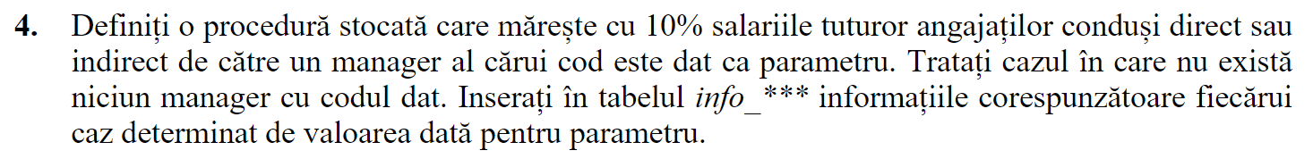

create or replace procedure ex4_pm (

cod_manager employees.manager_id%type default 100)

is

utilizator1 info_pm.utilizator%type;

manager1 number;

nr_linii1 number;

begin

select user into utilizator1 from dual;

select count(1) into manager1

from employees

where employee_id = manager1;

if manager1 = 0 then

insert into info_pm values(utilizator1, sysdate, 'test', 0, 'Nu exista niciun manager cu codul dat');

else

update employees

set salary = salary * 1.1

where manager1 in (select employee_id

from employees

start with employee_id = cod_manager

connect by prior employee_id = manager_id);

nr_linii1 := sql%rowcount;

rollback;

insert into info_pm values(utilizator1, sysdate, 'test', nr_linii1, NULL);

end if;

end ex4_pm;

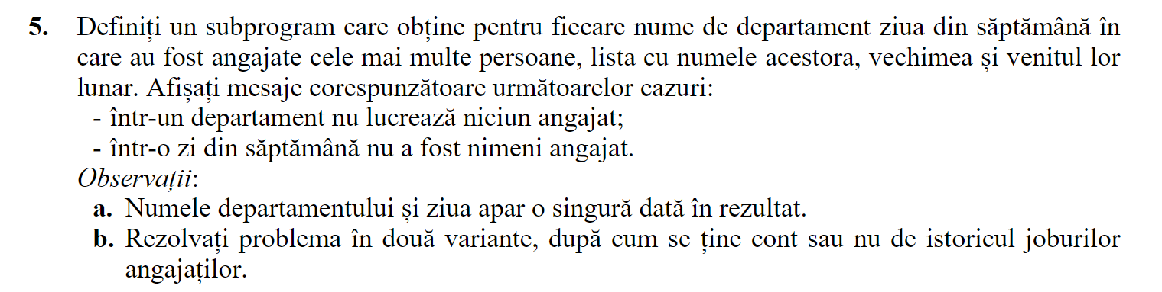

create or replace procedure ex5_pm

is

utilizator1 info_pm.utilizator%type;

nr_ang number;

nr_linii1 number;

zi varchar(10);

begin

select user

into utilizator1

from dual;

for d in (select * from departments) loop

dbms_output.put_line('Departament ' || d.department_id || ': ' || d.department_name);

select count(1)

into nr_ang

from employees

where department_id = d.department_id;

if nr_ang = 0 then

dbms_output.put_line('In departament nu lucreaza niciun angajat');

continue;

end if;

select day

into zi

from (select to_char(hire_date, 'day') day, count(1)

from employees e

where e.department_id = d.department_id

group by to_char(hire_date, 'day')

order by count(1) desc)

where rownum = 1;

dbms_output.put_line('Ziua in care au fost angajate cele mai multe persoane este: ' || zi);

for e1 in (select *

from employees

where department_id = d.department_id

and to_char(hire_date, 'day') = zi)

loop

dbms_output.put_line(e1.last_name || ' ' || e1.first_name || ' ' || e1.salary);

end loop;

end loop;

end ex5_pm;